
https://atlas.cid.harvard.edu/

Optimal Industry Development Strategy Using Economic and Product Complexity

Kuwait
─The Economic Complexity Lab - Columbia University
Ajit Akole, Alex Wei-Liang Ku, Sannidhya Modi, Alex Chung, Alexandra Garcia, Kelly Mi, Alex Chung, Margarita Demkina, Javier Arevalo
Optimal Industry Development Strategy for Kuwait

0. Executive Summary

In this report, we explore the economic path Kuwait followed during the period from 2013 to 2018. Specifically, we delve into the topic through a macroeconomic overview of Kuwait from the perspective of Gross Domestic Product (GDP) and Economic Complexity Index (ECI), which reflect countries’ production capability and production structure, respectively. We find that during the period of our interest, Kuwait demonstrated a relatively low level of economic growth with an average annual GDP growth rate of 1.54%, concurrent with a decrease in economic complexity as compared with other major developed economies. Average annual GDP growth increased to 3.4% in 2021, and its economic complexity decreased as a direct result of the pandemic, in line with other major developed economies during this time period.

The lack of progress during the period can be partially explained through analysis of the economic and product complexity structure of Kuwait on the industry group level. The product classification system we adopt allows us to measure the realized development for various industry groups and to observe that Kuwait consistently relied on developing the Energy Drilling and Mining industry during the period, while its developed counterparts and emerging economies around the globe have adopted much more complex and progressive paths.

Based on our analysis of the opportunity gain and a sensitivity analysis of major industry groups, Kuwait can further its gains by prioritizing High Complexity Products and Daily Instruments. We further note that Kuwait has a relatively mismatched development strategy that indicates a moderately low (compared to other developed countries such as Turkey) level of structural optimality on the complexity level, having an adjusted R-square of around 5.38%. A significant positive correlation exists between five-year GDP growth and the structural optimality index of an economy as we define and calculate, but Kuwait has a suboptimal growth experience as compared with fast-growing economies both on a regional scale and on a global scale. However, the country has the potential to further its economic gains through industrial structure optimization as suggested in the paper.

1. Report Overview

We aim to explore the economic path Kuwait followed during the period from 2013 to 2018 and the impact of COVID-19 on its economic development as observed in 2021. Specifically, we delve into the topic through a macroeconomic overview of Kuwait from the perspective of Gross Domestic Product (GDP) and Economic Complexity Index (ECI), which reflect countries’ production capability and production structure, respectively. We then analyze the industrial framework for Kuwait during the period based on quantitative measures such as Product Complexity Index (PCI) and Product Family Complexity Index (PfCI), followed by a detailed analysis of how changes to this framework have matched with development strategies as quantitatively measured by opportunity gains on an industry-level. We conclude our report with macro-level results and predictions of Kuwait, as deduced from regression models we have established on a global scale, which take into account countries’ stances in their product space.

2. Macroeconomic Results

2.1 GDP Ranking and Changes
Figure 1 illustrates the time-series GDP results for Kuwait and three of its peer countries (Sauda Arabia, United Arab Emirates, and Turkey) from 2013-2018. In contrast to the other countries, which generally displayed either constant or upward growth over all years, Kuwait had a noticeable dip in GDP from 2014-2015. Additionally, Kuwait’s average annual growth rate of 1.54% over the five-year period is lower relative to its peers, which are 3.22%, 3.88%, and 5.41% for United Arab Emirates, Saudi Arabia, and Turkey respectively.
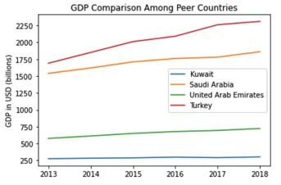
Figure 1: GDP Comparison Among Peer Countries (2013-2018)

Figure 2 illustrates the time series GDP results from 2019-2021. Both Kuwait and its comparable countries experienced a very similar trend, with a slight decrease in GDP from 2019 to 2020, followed by a strong recovery in 2021. The initial decrease can be attributed to the impact of COVID-19 and the onset of the pandemic. However, all countries were able to not only recover from the initial decline seen in 2020 but also increase their GDP to higher levels than before the pandemic. This is a strong indication that Kuwait and its comparable countries were successful in handling the economic challenges of the pandemic.
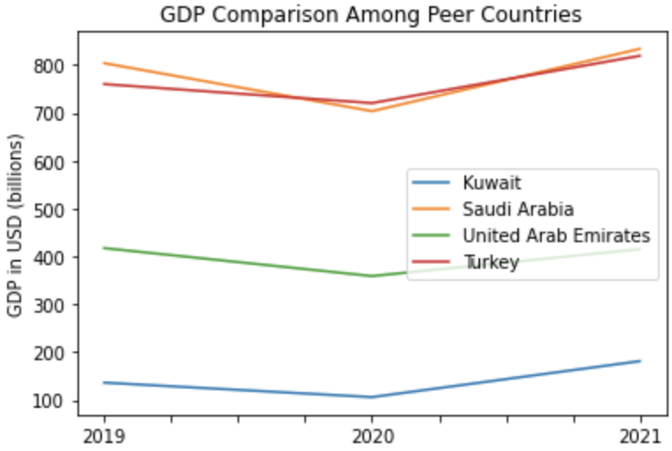

Figure 2: GDP Comparison Among Leading Economies (2019-2021)

2.2 ECI Ranking and Changes
The Economic Complexity Index (ECI), as defined by Ricardo Hausmann and Cesar Hidalgo in 2009 to explain the knowledge accumulated in a country's population, exhibits a similar growth pattern for Kuwait. As illustrated in Figure 3 below, Kuwait (76.91% ECI change) exhibited an increase in terms of its production capability from 2013 to 2018, to a much smaller extent than Turkey (473.18%) compared to decreases in the United Arab Emirates (-18.38%) and Turkey (-21.27%). Ultimately, Kuwait performs moderately amongst its peer country set, as it displays a low GDP growth rate and relatively median ECI change across the period.

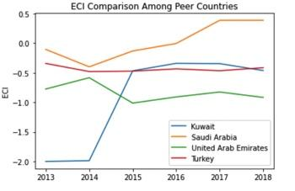
Figure 3: ECI Comparison (2013-2018)

However, as shown in Figure 4, Kuwait’s ECI did not change as drastically as the ECI did for its comparable countries. Kuwait experienced a slight decrease in its ECI index during the period between 2019 and 2020. No data was available for the ECI index for Kuwait during the year 2021. Turkey experienced a similar trend as Kuwait, with no significant change during the period. United Arab Emirates was the only one among the comparable countries group which experienced a significant increase in its ECI level. It was the only country to show positive growth during the period between 2019 and 2020 and then experienced an even more significant increase between 2020 and 2021. Saudi Arabia experienced a slight increase followed by a drastic decrease in its ECI index.
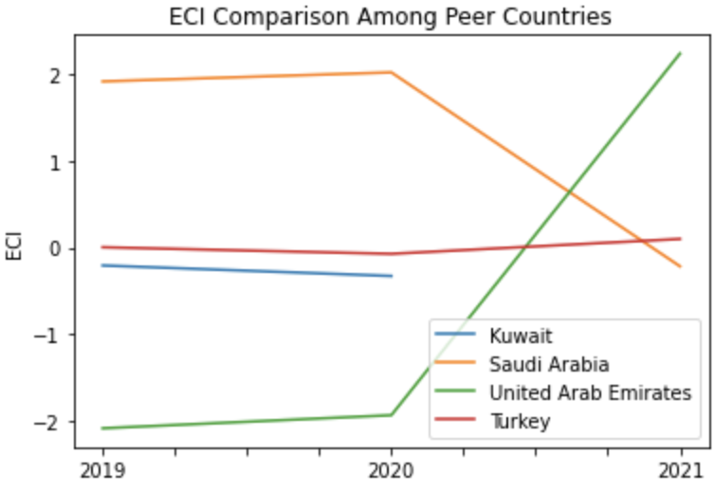

Figure 4: ECI Comparison (2019-2021)

Figure 5 offers a further comparison of GDP growth and ECI over the time span from 2013 to 2018 for Kuwait. The increase in GDP during the period from 2013 to 2018 is accompanied by an initial period of sharp growth followed by a plateau in ECI. The results show that the economic growth experienced by Kuwait during the period from 2013 to 2018 is not optimally consistent with the predictions by ECI, and Kuwait can make more improved strides to develop a competitive product space that helps to accumulate complex knowledge and technology. In order to provide a more concrete answer to why this has happened, we will dive into an analysis of Kuwait’s production structure and its product space designs in the next few chapters.
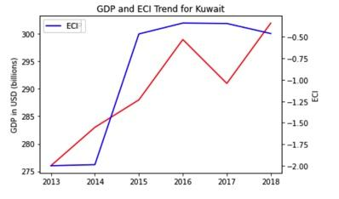

Figure 5: GDP Growth and ECI Kuwait (2013-2018)

Figure 6 compares GDP growth and ECI between 2019 and 2021 for Kuwait. GDP experienced a significant decrease in 2020, mainly due to the onset of the COVID-19 pandemic. However, Kuwait’s GDP was able to recover by 2021, a year in which it experienced significant growth. Kuwait’s ECI decreased drastically from 2019 to 2020.
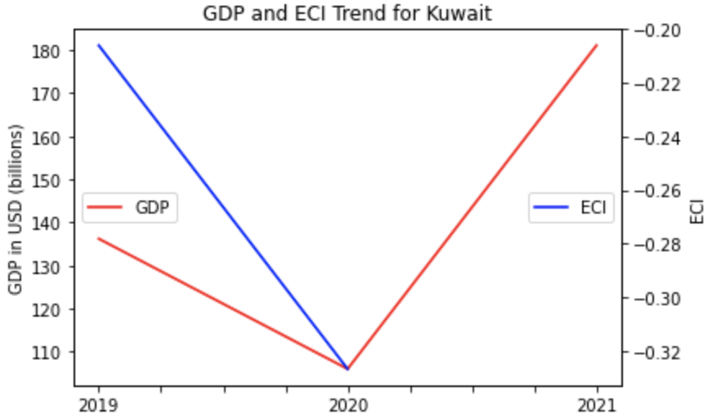

Figure 6: GDP and ECI (2019-2021)

3. Production Analysis

3.1 Product Categorization
Our main data source in this research is the UN Comtrade Website (https://comtrade.un.org), which provides us with valuable information on countries’ export values on an annual basis, including highly specific export data for more than 5,000 categories of products. In order to have a holistic vision of the product space of a country, however, a level of categorization is required. Products in our data source are labeled from 010000-999999, with the first two-digits representing a general category to which the product belongs. Based on the 99 categories as extracted from the label, we further group the products into 18 most widely-accepted industries, as summarized in Table 1.

Note that the High-complexity Products industry group is not a distinct industry but rather an aggregated industry that encompasses the most complicated products from the most technologically-advanced industries (as measured by PCI). This industry serves as an indicator for us to quantitatively evaluate how well a country has performed in developing cutting-edge technologies and closing its technical gap with advanced economies, which has become a topic of wide concern today. Indeed, when we rank the 18 categories based on PfCI (an equivalent concept of PCI as calculated based on the 18 categorized product groups), the High-complexity Products industry has the highest PfCI among all industry groups.

Category | Description
Animals and By-products | All kinds of meat, livestock and related by-products
Vegetables, Fruits and Plants | All kinds of plants, edible vegetables and fruits
Food and Preparations | Edible preparations, raw cooking materials and appliances
Clothing and Accessories | All kinds of fabrics, filament, clothing and accessories
Textiles | All kinds of textile articles and related products
Wood Products | Book, paper and other elementary products related to wood
Metals | Mining of all sorts of raw Metals
Refined and Processed Stones | Refined or processed stone products such as pearl and ceramics
Energy Drilling and Mining | Mining industry for energy, minerals, stone materials, etc.
Daily Instruments | Basic daily instruments such as sport requisites, timing and measuring tools
Raw Manufacturing | Basic products made from plastic, rubber, leather, etc.
Chemical Manufacturing | Advanced chemical products and pharmaceutical products
Chemicals | Raw chemical materials and by-products
Machinery and Construction | Machinery and mechanical appliances, including electrical equipment
Transportation | Vehicles and locomotives including aircraft, ship, railway, etc.
Weapons | Explosives, arms and ammunition
Services and Utilities | Financial, business, legal, communication, travel Services and Utilities, etc.
High-complexity Products | Agglomeration of advanced products with highest PCIs

Table 1: Categorization of Products

We further observe a positive correlation between GDP and the export of High-complexity Products. A higher adjusted R-square exists between GDP and High-complexity Products exports, indicating that more successful economies, as measured by GDP, tend to be those that are capable of producing and exporting High-complexity Products as we define them. Figures 3 and 4 show the OLS results in a universe of 107 and 21 typical countries, respectively.

 | High-complexity Products | Food and Preparations | Animals and By-products
Adj.R-squared | 0.075 | 0.006 | 0.002
F-statistic | 9.556 | 1.638 | 1.175
No. Observations | 107 | 107 | 107

Figure 3: OLS Regression Results of GDP against Percentage Volume of Exports

 | High-complexity Products | Food and Preparations | Animals and By-products
Adj.R-squared | 0.149 | 0.003 | -0.012
F-statistic | 4.510 | 1.059 | 0.7542
No. Observations | 21 | 21 | 21

Figure 4: OLS Regression Results of GDP against Volume of Percentage Exports

3.2 Realized Industry Development
Based on the product categorization aforementioned, we aim to capture Kuwait’s realized industry production strategy between 2013 and 2018 on a complexity level. In Hausmann and Hidalgo (2009), distance is defined to be a measure of how far a country is from a certain product not in its product space. We extend this concept to all product groups and quantify how technically equipped a country is to develop the corresponding product groups. In other words, the shorter the distance between a country and a product group, the more capable a country is in developing products within that group. Defining this net distance change as the Realized Industry Development (RID), our export data allows us to calculate and compare RID of Kuwait and the 18 product groups in 2018 and 2021 through subtraction, where a positive RID indicates a shortening of the distance (i.e., advancement of the industry), and a negative RID indicates the reverse.

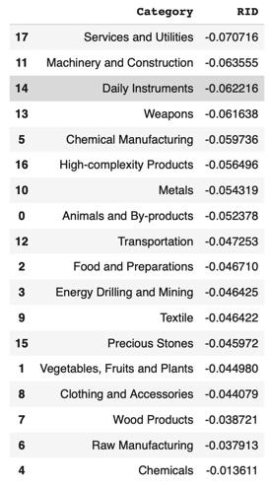
Table 2: Realized Industry Development (RID) of Kuwait (2013-2018)

3.3 Regional and Global Comparison
Tables below summarize how the production strategy adopted by Kuwait compares with leading economies and a selected group of emerging economies in the world, as measured in RID.

Ranking | France | the UK | Germany
1 | High-complexity Products | Services and Utilities | High-complexity Products
2 | Chemical Manufacturing | Weapons | Transportation
3 | Daily Instruments | Raw Manufacturing | Wood Products
4 | Animals and By-products | Precious Stones | Metals
5 | Food and Preparations | Animals and By-products | Food and Preparations
Table 4a: RID Comparison across Leading Economies (2018)

Ranking | France | the UK | Germany
1 | Services and Utilities | Precious Stones | Daily Instruments
2 | Precious Stones | High-complexity Products | Transportation
3 | High-complexity Products | Services and Utilities | Chemicals
4 | Energy Drilling and Mining | Energy Drilling and Mining | Chemical Manufacturing
5 | Machinery and Construction | Wood Products | Clothing and Accessories
Table 4b: RID Comparison across Leading Economies (2021)

Ranking | China | South Korea | Singapore
1 | High-complexity Products | Transportation | Transportation
2 | Transportation | Textile | High-complexity Products
3 | Machinery and Construction | High-complexity Products | Precious Stones
4 | Energy Drilling and Mining | Chemical Manufacturing | Daily Instruments
5 | Daily Instruments | Machinery and Construction | Services and Utilities
Table 4c: RID Comparison across Emerging Economies (2018)

Ranking | China | South Korea | Singapore
1 | Chemicals | Chemicals | Weapons
2 | Daily Instruments | Daily Instruments | Energy Drilling and Mining
3 | Transportation | Transportation | Transportation
4 | Raw Manufacturing | Textile | Machinery and Construction
5 | Weapons | Raw Manufacturing | High-complexity Products
Table 4d: RID Comparison across Emerging Economies (2021)

Table 4c and 4d further examine Kuwait’s development strategy against those of emerging economies on a global scale. Reasonably, emerging economies such as China, South Korea, Singapore, and India have devoted the majority of their efforts to intermediate industry groups.
While developing countries such as Kuwait should have relied more on essential or more basic industry groups. This trend holds true in general, regardless of the continent or the time period, and serves as an indicator for which phase of development a country is currently in as evaluated from its production strategy. Based on this standard, Kuwait is adopting a strategy that seeks development in industry groups of lower complexity. Given the economic impacts of COVID-19, this is not an out-of-phase strategy, but as the economy recovers over the coming years, it should shift its focus on developing a strategy to focus on industry groups with higher complexity.

4. Product Space Design

4.1 Suggested Development Vector
As aforementioned, distance gives us an idea of how far each new product is from a country’s current mix of exports. As defined in Hausmann and Hidalgo (2009), distance is “the weighted proportion of products connected to goods p that country c is not exporting, i.e., MCP = 0.” Based on this definition, the distance between a country and any product that the country is currently exporting (i.e., the country is a significant exporter in the product as compared to global average) is zero. Similarly, opportunity gain quantifies the contribution of a new product in terms of opening up the doors to more and more complex products. Intuitively, a product that a country is currently exporting (i.e., MCP = 1) has an opportunity gain of zero. An unreasonable investment in a certain product p would lead to a relative decrement in the export of more profitable products, and therefore lead to a negative opportunity gain of product p. The opportunity gain is not the only estimator of a country’s level of economic development. However, among countries with comparable economic strength, those having higher ECI, or in other words, more reasonable economic structures are often in better shape.
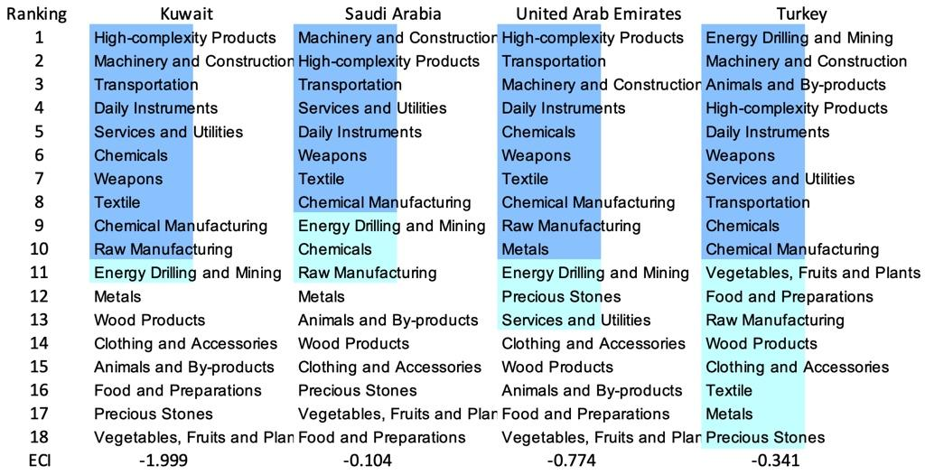

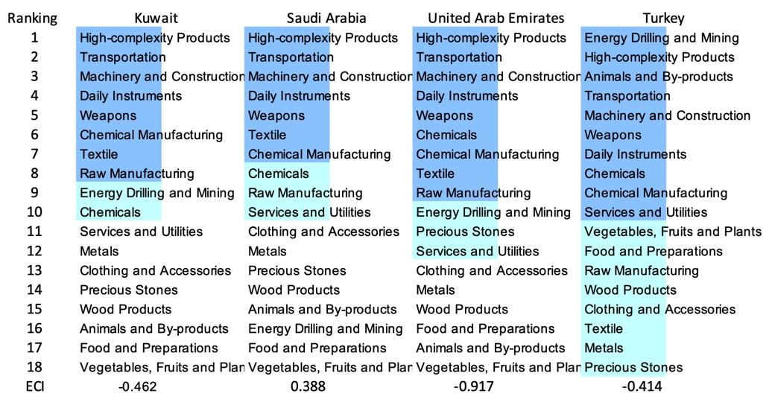
Table 5: SDV of High E_{f}CI Countries 2013 (up), 2018 (down)

We define the ranking of opportunity gain for a country c, as the Suggested Development Vector (SDV) of c. Table 5 and 6 summarize how the SDV of Kuwait compares with a selected group of comparable and leading economies in the world, with the industry groups ranked in decreasing order of significance. Dark blue indicates positive opportunity gain, light blue indicates zero opportunity gains, and white indicates negative opportunity gains. The result shows that leading countries barely have any industries with positive opportunity gain. In other words, those countries are already in the most stable and efficient economic structure. Without the necessity of economic transition, those countries merely need to maintain a steady and balanced economic development. In contrast, developing countries have nearly half of industries with positive opportunity gain, and share common interests in industrial manufacturing and High-complexity Products industries. It can be concluded that Kuwait shares the characteristics of developing countries, with a balanced economic structure that leans towards intermediate-level industries.



Table 6: SDV of Other Typical Countries 2013

4.2 Budgeted Industry Development Strategy and Interpretation

The optimal budgeted industry development strategy aims to solve the most efficient allocations under the budgeted constraint of different situations of heuristic total export growth. In order to obtain such an allocation portfolio, we formulate an optimization problem as the following:



where k(x) is the second-largest eigenvector of $M_{CC'}$ after adding $x$ to the original export vector, C is the country that we are interested in, P is the product space, B is the heuristic budget.

If we can solve this problem, then we can know what the largest ECI that a country can improve to. Accordingly, the optimal solution $x*$ that we obtain here is exactly our optimal allocation. However, the biggest problem is that the objective function is not convex. Therefore, we cannot apply the classical tools for convex optimization to this problem. In order to solve this problem, our idea is to use a greedy algorithm. The way that we apply the greedy algorithm is that we first separate the total budget into k equal parts, and then for the first equal part, we try to search for the product that can optimize our objective function by iterating through each $p∈P$. After we find the optimal product p for this equal part, we add the amount back to the export value of this product p and update the ECI for this country. If we observe that ECI does not change after iterating all the products, then we can add up one more equal part to invest. Until we find there is an ECI increment, we add the amount now to that product. The rest of the equal parts can be done in the same way.

However, as is known to all, the greedy algorithm is a kind of local search algorithm, which is quite possible to run into a local minimum. Therefore, for local search algorithms, one typical way to keep it away from the local minimum is to enhance the vision of the algorithm by looking more steps forward. In our setting, whenever we obtain an increment of ECI, we mark down the required amount of export growth. Simultaneously, we continue searching for the next ECI increment point, compare the ratios of these two possibilities, and pick the largest one. The ratio is defined as the following:


where ${ECI}_{p}$ is just the ECI of the country after adding some amount of export increment to product $p$, which is exactly the amount that is able to make ECI change. Also, we can express it in the way of $||$$x_{p}-x_{0}$${||}_{1}$.

In this way, we can obtain a further sighted greedy algorithm. Also, the number of parts that we would like to separate the budget into also matters. In order to solve this problem, we added a stabilizer on top of the enhanced greedy algorithm, by running the algorithm for different numbers of parts and selecting the portfolio with the largest ECI increment and most complex economic structure.

Besides, it is quite common that there is a surplus for the budget. To deal with the surplus, we just add it to the product which needs the least amount of dollar to make $M_{cp}$ = 1, (i.e., the smallest amount of required export increase).

Interpretation:

For the purpose of a clear explanation of the line charts, we try to label all the products in Table 7. Please refer to this table when trying to understand the investment trajectories in the line charts.

Label | Product Names
1 | Animals and By-products
2 | Vegetables, Fruits and Plants
3 | Food and Preparations
4 | Energy Drilling and Mining
5 | Chemicals
6 | Chemical Manufacturing
7 | Raw Manufacturing
8 | Wood Products
9 | Clothing and Accessories
10 | Textile
11 | Metals
12 | Machinery and Construction
13 | Transportation
14 | Weapons
15 | Daily Instruments
16 | Precious Stones
17 | High-complexity Products
18 | Services and Utilities

Table 7: Products Labeling

Below is the economic panel for Kuwait in 2013. We can see that for different percentages of heuristic total export growth, the ECIs of Kuwait have different amounts of increments. A 5% export growth results in an ECI improvement pattern of around -1.999 and ends at around 0.361. The ECI improvement pattern is similarly positive for a bit and then plateaus for export growth of 10%, 15%, and 20%. In particular, the ECI for 10% export growth ends at around 0.374. For the 15% growth budget, the ECI of Kuwait ends at around 0.359, and for the 20% growth budget, the ECI ends at around 0.871.

For the case of 5 percent export growth, Services and Utilities account for the majority of the portfolio. For 10 percent export growth, more weight is awarded to Weapons, suggesting that with low economic improvement anticipation, Finland should focus more on developing this industry. Going to 15 percent export growth, we see that Wood Products is now the heavily recommended strategy, while 20 percent growth recommends the majority in Machinery and Construction. Thus, there is a very different distribution for each level of export growth. A more detailed numerical representation of the portfolio is shown in Table 8.

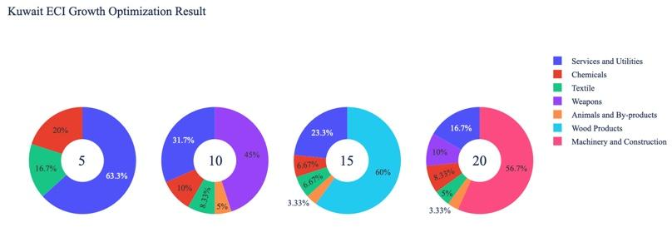
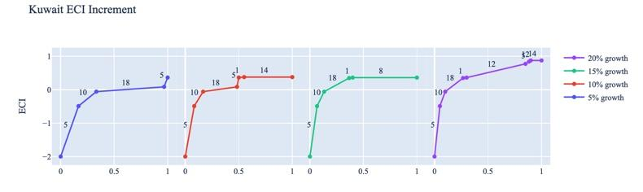

Figure 5: Greedy Based ECI Improvement Results of Kuwait in 2013 with Different Budgets

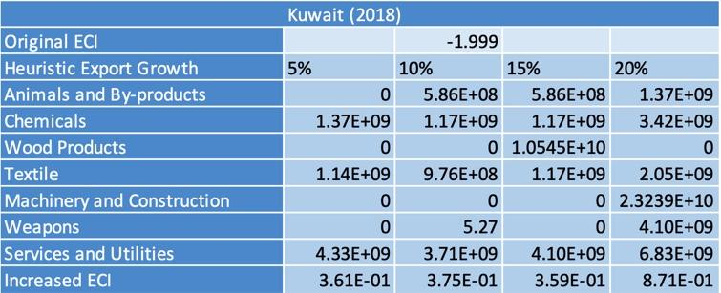
Table 8: Portfolio of Kuwait in 2013

For further suggestions on Kuwait’s development in the future, we also offer the optimization result of Kuwait based on export data in 2018. Below is the economic panel for Kuwait in 2018. We can see that there is a similar pattern for the ECI improvement trajectories, but the growth trajectories do not plateau as they did previously, instead continuing to trend upwards continuously for all percentages of growth. Also, we notice that the main components that result in ECI improvements are not similar. For a 5 percent export growth, the improvement is now concentrated in Raw Manufacturing, while for 10, 15, and 20 percent growth, it is increasingly concentrated in Chemical Manufacturing and Daily Instruments. A more detailed numerical representation of the portfolio is shown in Table 9.

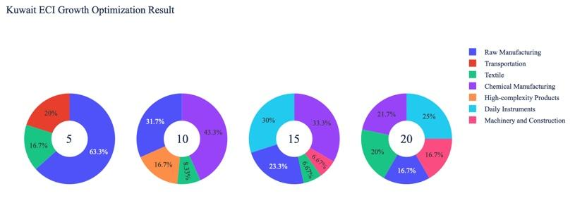
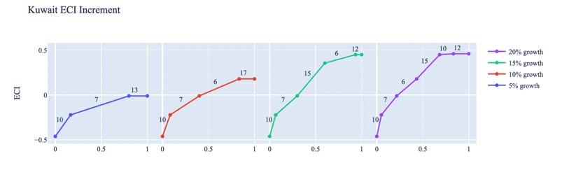
Figure 6: Greedy Based ECI Improvement Results of Kuwait in 2018 with Different Budgets

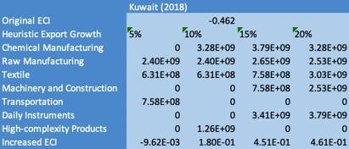

Table 9: Portfolio of Kuwait in 2018
4.3 Sensitivity Analysis and Contingency Strategy
In the following section, our broad aim is to understand how sensitive Kuwait is to changes in export in various industries. While the Economic Complexity Index has been shown to contain valuable information about the economic strength/capacity of a country, little has been said as to the stability of the measure itself. We seek to uncover the main drivers of stability under a country's ECI score and better understand longer-term projections for ECI growth. Additionally, gaining an intuition on the industries that are bolstering an economy and the industries that offer the greatest return per unit of investment is best done through visualization of industry-specific sensitivity. To this end, we have developed two categories of sensitivity analysis.
ECI Sensitivity Graph
Firstly, in order to assess the effect particular industries have on each respective country, we developed ECI Sensitivity graphs. We use the shocking methodology to increment or decrement an industry’s export level by a certain percentage and recalculate the ECI, all else being equal. While freezing the export dynamics of the rest of the world and enacting an instantaneous shock in export for a particular industry and country may not reflect real-life dynamics, what it does offer us is an understanding of a country’s level of dependency on an industry in the context of ECI. The shocking is done in small percentage increments in order to smooth out the resulting curve. Additionally, a recurring theme one will see is that for most industries, a breaking point occurs where the ECI either jumps upwards or downwards, creating a hockey stick shape rather than a linear trend. While the inflection point may not be accurate in the context of real life, comparing the various inflection points across industries can give us valuable insight.
The graphs are formulated as follows: There are four ECI Sensitivity graphs. The first two represent data from 2018. The first chart shows positive shocks in which export numbers are shocked upwards per industry. The X-axis is in terms of percentage shock per current dollar value of export. The Y-axis is the recalculated ECI level post-shocking. The second chart follows the same format except the X-axis represents negative shocking. In other words, exports for each industry are decremented and the ECI is accordingly recomputed. The final two sensitivity graphs show the same results using 2013 data. Below is an example of an ECI sensitivity graph.

Example 2018 (Incremental ECI Sensitivity)

SDV Sensitivity
Secondly, we analyze the sensitivity of the SDV to changes in export levels. The goal is to understand how export level changes for a particular industry can affect the marginal opportunity gain for other industries. We will be using specifically High Complexity Products and Food and Preparations as our base industries. We will be increasing or decreasing the absolute export level in both of these industries and observing the effects on the SDV.
When the opportunity gain of an industry is negative, the SDV sensitivity approximates how an over-development of the industry jeopardizes the economic structure of a country. When the opportunity gain of the industry is zero, the SDV sensitivity determines whether the further development of the industry shapes the country with a better economic structure and predicts how the SDV would change accordingly. Specifically, as we reduce the export of such an industry to 25%-50% of its original value, a few other industries originally with negative opportunity gain could likely become profitable.
Similar to the ECI sensitivity graphs above, we will be shocking the export of High Complexity Products and Food and Preparations in small percentage increments. A new SDV, represented by a new column in the charts, is recorded only when a certain level of shock changes the structure of the SDV. In effect, we are incrementing or decrementing export levels of two industries until the marginal opportunity gain of any industry changes in category (positive, negative, or neutral). Below is an example of an SDV Sensitivity chart with Positive Shocking. Industries with positive marginal opportunity gain are colored blue, neutral is colored white, and negative is colored red.


Example High-complexity Products 2018 (Incremental SDV Sensitivity)

Contingency Plan
The Contingency Plan aims to present a set of solutions with respect to upheavals in different industries. Instead of compensating for the declining production directly, the best strategy is to develop those incipiently profitable industries. In this manner, we can derive the contingency strategy for countries to deal with possible abrupt declines of crucial industries. In some cases, the SDV remains unchanged even when a zero-opportunity-gain industry declines to its 20% in terms of export. We can then conclude the industry is not indispensable to the country. As a clarification, the three consecutive N/As mean that the country doesn’t even need to respond to a collapse in the industry. Countries tend to have distinct solutions to the ups and downs of the same industry. To create the contingency strategy table, we decrease the export level for each industry in the country’s current production space by 60% respectively. The three highest ranking industries in the new SDV are then returned.


Example Contingency Strategy 2018

4.3 Sensitivity Analysis Results and Interpretation

Below are Kuwait’s 2013 ECI Sensitivity Charts. Firstly, in the positive chart, we notice immediately that increases in High-omplexity Products and Daily Instruments lead to an uptrend in ECI. In particular, Daily Instruments offer the best ECI growth per unit of export increase. All other industries besides the two mentioned above tend not to greatly affect the ECI level, making it fairly clear which industries to pursue.

Next, we consider Kuwait’s 2013 Negative Shock chart. We see that Kuwait’s ECI is not very highly sensitive to drawdowns in any particular category, but we see that large decreases in Energy Drilling and Mining seem to greatly increase the ECI score. These industries are very important for Kuwait’s economy, and thus the results reflected in the chart may suggest that there is another industry that could be very beneficial for Kuwait that is far in proximity from the Energy Drilling and Mining industries.

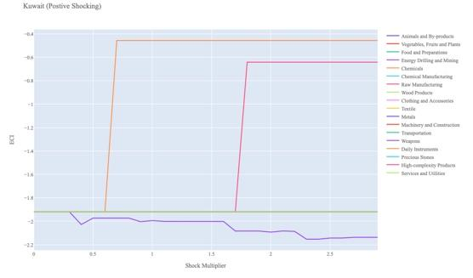
Kuwait 2013 (Incremental ECI Sensitivity)
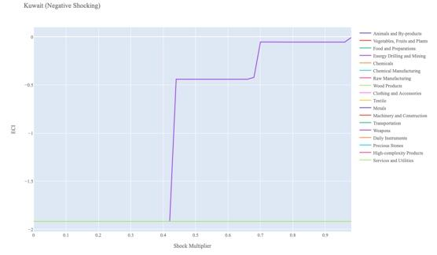

Kuwait 2013 (Decremental ECI Sensitivity)

Next, we consider the 2018 ECI Sensitivity graphs. We see that in the positive shock case, the landscape of ECI sensitivity has altered a bit over the five-year period. Daily Instruments still seem to offer positive ECI growth prospects, and Kuwait is sensitive to negative ECI growth due to Energy Drilling and Mining.

In the 2018 negative shock case, we see that Kuwait is sensitive to drawdowns in Chemicals and would benefit in ECI growth from Energy Drilling and Mining.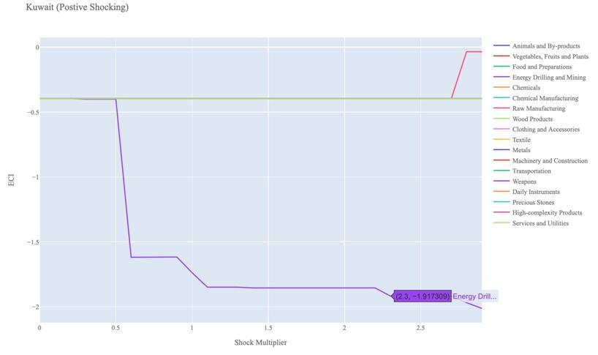

Kuwait 2018 (Incremental ECI Sensitivity)

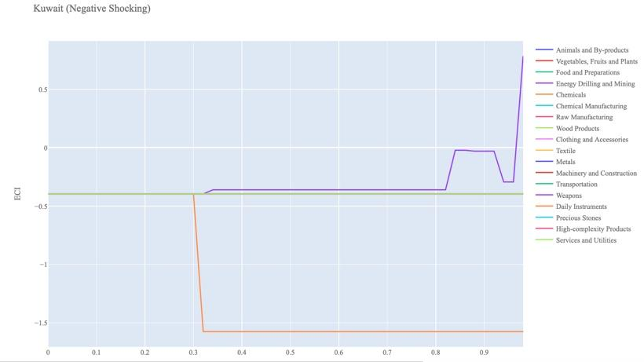

Kuwait 2018 (Decremental ECI Sensitivity)

Below, we see the SDV sensitivity charts for Energy Drilling and Mining. We see that increasing the export of Energy Drilling and Mining opens up many positive opportunity gain industries for Kuwait to move into.

In the negative Energy Drilling and Mining SDV chart, we see that as we decrease the export of Energy Drilling and Mining products, the exact opposite happens. The number of industries with positive opportunity gain shrinks, suggesting that the opportunities available to Kuwait are highly dependent on its Energy Drilling and Mining footprint.

Concerning Food and Preparations, Kuwait seems to be mostly insensitive to this industry, suggesting that this is not an important industry in terms of the stability of its SDV.

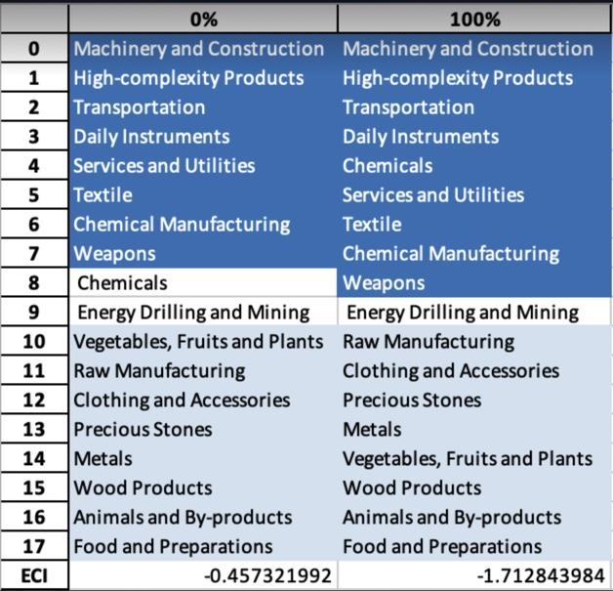
Kuwait High-complexity Products 2018 (Incremental SDV Sensitivity)

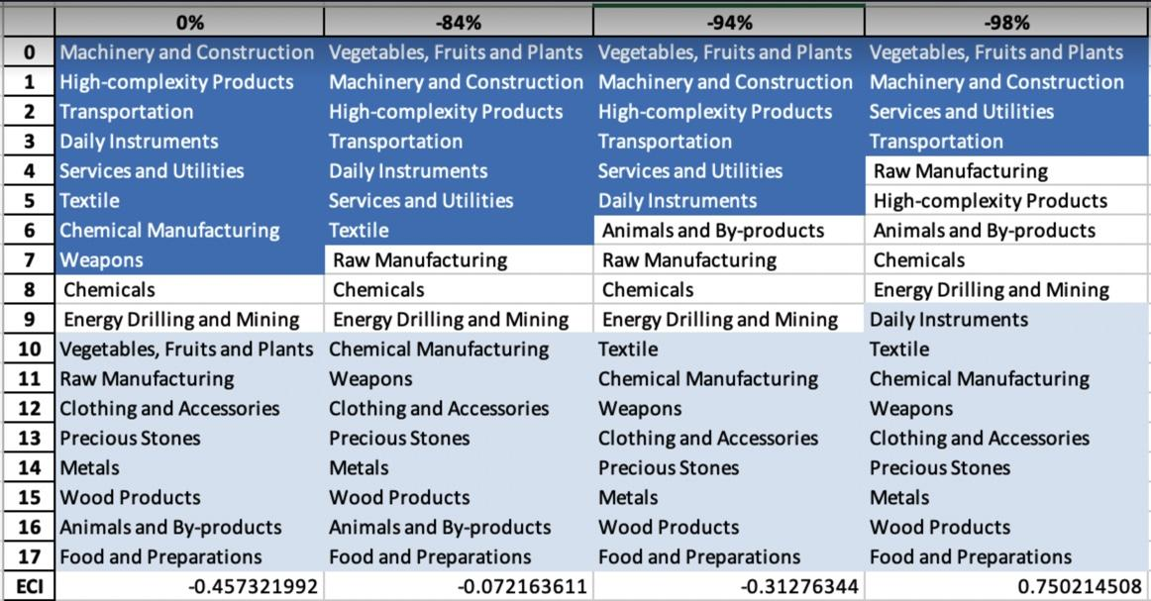
Kuwait High-complexity Products 2018 (Decremental SDV Sensitivity)

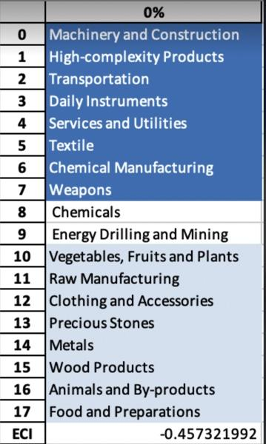
Kuwait Chemicals 2018 (Incremental SDV Sensitivity)

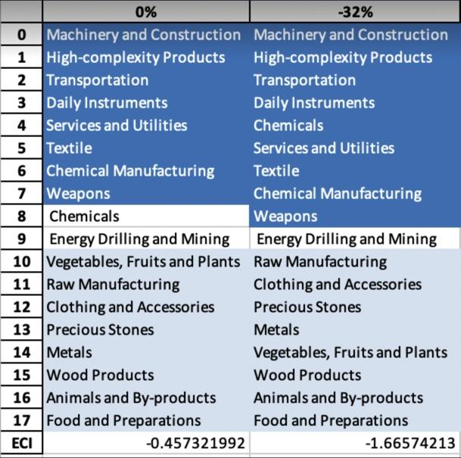Kuwait Chemicals 2018 (Decremental SDV Sensitivity)

4.4 Contingency Strategy

By decreasing the export of each industry in Kuwait’s current production space by 60% respectively, we derive the contingency strategy shown below.

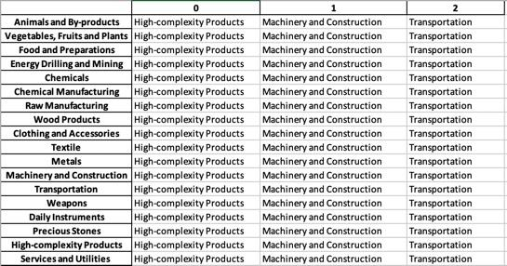
Kuwait Contingency Strategy 2018

5. Macro-level Predictions

5.1 Structural Optimality Index
Indeed, such a choice of prioritization has proven to be a significant factor in deciding the economic outcomes of countries. In order to quantitatively evaluate how effective our development strategies are and how deviations from the suggested developmental path will lead to suboptimal growth results, we define the measure – Structural Optimality Index (SOI) – on a country level as the Adjusted R-Square obtained from regressing the country’s realized industry development over the suggested development strategy. Both strategies are quantified in nature, with the realized development represented by export increase in every major industry group and the suggested development strategy represented by the opportunity gains of developing the corresponding industry groups as calculated in previous sections. The adjusted R-square from the regression thus provides us with a quantified measure of how the development path adopted by the country has fitted with/differed from calculations on a complexity level.

After obtaining this measure for all countries in our database, we further regress countries’ five-year economic growth, which is defined as the percent increase in GDP (USD), over their SOI. Figure 6 illustrates the regression output, which shows a strong positive correlation between countries’ SOI and their five-year GDP growth, significant at the 1% level and achieving an adjusted R² of 4.5%. In other words, the more a country develops as suggested by calculations on a complexity level, the better economic outcomes it achieves.

Table 18: OLS Regression Results
Dep. Variable: GDP | F-Statistic: 5.963
R²: 0.054 | Prob (F-Stat): 0.0163
Adj R²: 0.045 | No. Observations: 106

Figure 2: Regression of Five-year GDP Growth over SOI

5.2 SOI of Kuwait and Its Implications
Kuwait, for instance, has a low level of structural optimality as compared with its developed peers. As the regression in Figure 7 suggests (the orange curve represents export increase and the blue curve stands for opportunity gain of the corresponding industry), Kuwait demonstrates a low level of correlation with the suggested developmental path, having an adjusted R-square of around 5.38%. Kuwait ranks in the lower quartile among all countries in terms of SOI and has made a low rate of economic progress below its developed peers from 2013 to 2018 with a 5-year GDP growth rate of 1.54%, which is consistent with the regression result in Figure 6. This is in direct contrast to other developed economies such as Japan, where there is a low SOI of around -5.7% and a corresponding GDP growth of 9.05% from 2013 to 2018, making Kuwait a much slower developing economy during the period. In sum, Kuwait’s mixed economic progress from 2013 to 2018 can be at least partially explained by a development strategy that demonstrates a suboptimal level of alignment with our suggested developmental path. Specifically, Kuwait invested heavily in the Chemicals and Raw Manufacturing industry, while it should have focused more on more complex industry groups such as Energy Drilling and Mining. That being said, it stayed fairly in line with our expectations in the Precious Stones industry.

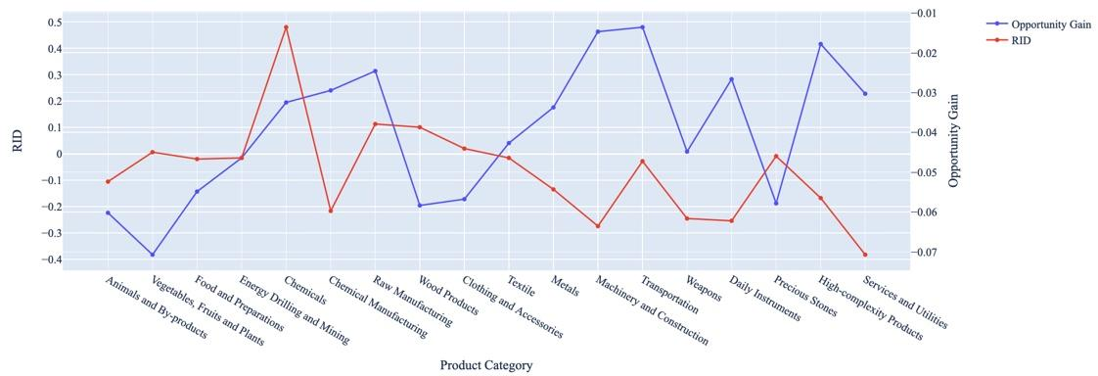
Figure 7: SOI of Kuwait (2013-2018)

6. Concluding Remarks

In conclusion, Kuwait has demonstrated a moderately low level of economic growth in terms of annual GDP increase during the period from 2013 to 2018, concurrent with a decrease in economic complexity as compared with other major developed economies.

The lack of progress during the period, we believe, can be partially explained through analysis of the economic and product complexity structure of Kuwait on the industry group level. The product classification system we adopt allows us to measure the realized industry development for various industry groups and to observe that Kuwait consistently relied on developing the Energy Drilling and Mining industry during the period, while its developed counterparts and emerging economies around the globe have adopted much more complex and progressive paths.

Based on our analysis of the opportunity gain and a sensitivity analysis of major industry groups, Kuwait can further its gains by prioritizing Chemical Manufacturing and Daily Instruments. We further note that Kuwait has a slightly mismatched development strategy that indicates a moderately low (compared to other developed countries) level of structural optimality on the complexity level, having an adjusted R-square of around 5.38%. Since a significant positive correlation exists between five-year GDP growth and the structural optimality index of an economy as we define and calculate, Kuwait, however, still has a suboptimal growth experience as compared with fast-growing economies both on a regional scale and on a global scale, and has the potential to further its economic gains through industrial structure optimization as suggested in the paper.

References

Hausmann, R., Hidalgo, C., Bustos, S., Coscia, M., Chung, S., Jimenez, J., Simoes, A. and Yıldırım, M. (2007). The Atlas of Economic Complexity. [online] Atlas.cid.harvard.edu. Available at: http://atlas.cid.harvard.edu/.

Balassa, B., “The Purchasing Power Parity Doctrine - A Reapprais- al,” Journal of Political Economy 72, 584-596 (1964).

Feenstra, R.; Lipsey, R.; Deng, H.; Ma, A. & Mo, H. “World Trade Flows: 1962-2000” NBER working paper 11040. National Bureau of Economic Research, Cambridge MA (2005).

United Nations Commodity Trade Statistics Database (http://comtrade.un.org/db/), accessed in August 2019.

The World Economic Forum, “The global competitiveness report,” (various years).

Barro, R. & Lee, J-W. “A New Data Set of Educational Attainment in the World, 1950-2010,” NBER Working Paper No. 1590 (2010).

Kaufmann, D. & Kraay, A. “Governance Indicators: Where Are We, Where Should We Be Going?” Policy Research Working Paper 4370. Washington, DC: World Bank (2008).

Hanushek, E.A. & Woessmann, L. “The Role of Cognitive Skills in Economic Development,” Journal of Economic Literature 46(3), 607- 668 (2008).

